**“DISORGANIZED FURNITURE ORDER DETAILS WITH FOCUS ON DIGITAL MANAGEMENT OF CLIENT DESIGNS, MEASUREMENTS AND INSTRUCTIONS”**

**SYSTEM PROPOSAL**

**SUBMITTED BY,**

**Carlton Gitonga Njoki,**

**DIT-01-0061/2025**

**A RESEARCH SYSTEM PROPOSAL SUBMITTED IN FULFILMENT FOR PROGRESSION TO SYSTEM PROJECT, TO THE DEPARTMENT OF ICT AND ENGINEERING OF ZETECH UNIVERSITY**

**AUG, 2025**

**DECLARATION**

I declare that the contents of this paper are as a result of personal research and all external sources from reading have been appropriately referenced. This paper does not contain AI-generated content. No version of this research paper has been submitted in this exact version to any other institution***.***

***Student Name: ____________________________ Sign: _________________ Date: __________***

***Supervisor Name: _________________________ Sign: _________________ Date: __________***

**ABSTRACT**

This study proposes a web-based digital management system made especially for furniture makers to streamline the processing of client designs, measurements, and instructions. It draws attention to problems with the manual and fragmented digital processes that are now in use, which frequently result in manufacturing errors, delays, and unhappy customers. It investigates contemporary digital tools, automation techniques, and platforms that improve data security, accuracy, and workflow efficiency through a review of the literature and a feasibility study. The proposed system uses open-source technologies including HTML, CSS, JavaScript, and Firebase to offer a cost-effective solution. The technology aims to lower operating expenses, boost customer happiness, and promote business expansion by automating order administration. It provides the framework for developing a full-stack solution that satisfies both academic and industry criteria.

**TABLE OF CONTENT**

Contents

**ABSTRACT** iii

**LIST OF TABLES** v

**Table 3.2** Feasibility Assessments v

**DEFINITION OF KEY TERMS** vi

**ABBREVIATION AND ACRONYMS** vii

**CHAPTER ONE: RESEARCH OVERVIEW** 1

**1.1 Statement of Problem** 1

**1.2 Study Justification** 1

**1.3 Research Objectives** 1

**1.3.1 General Objective** 1

**1.3.2 Specific Objectives** 1

**1.4 Scope of the Study** 2

**CHAPTER TWO: LITERATURE REVIEW** 3

2.1 **Introduction to Literature** 3

**2.4 Conclusion of Literature** 5

**CHAPTER THREE: WORKPLAN** 6

**3.1 Introduction** 6

**3.2 Feasibility Assessments** 6

**Table 3.2 Feasibility Assessments** 6

**3.3 Project Justification** 7

# **LIST OF TABLES**

**Table 3.2** Feasibility Assessments

**DEFINITION OF KEY TERMS**

**Digital Management System:** A software platform used to organize, store, and retrieve client data digitally.

**Client Designs:** Visual or technical representations of furniture requested by customers.

**Measurements:** Specific dimensions provided by clients for custom furniture production.

**Instructions:** Detailed guidelines or preferences from clients regarding furniture orders

**Centralized Platform:** A unified system where all data is stored and accessed from a single location.

**Automation:** Use of technology to perform tasks with minimal human intervention.

**ERP (Enterprise Resource Planning):** Integrated software that manages core business processes like inventory and CRM.

**CAD (Computer-Aided Design):**  Software used to create precise drawings and models for furniture design.

**Firebase:** A Google-backed platform offering backend services like database and hosting.

**Feasibility Assessment:** Evaluation of a project's practicality based on technical, budgetary, and time constraints

**ABBREVIATION AND ACRONYMS**

**DMS** – Digital Management System

**CAD** – Computer-Aided Design

**ERP** – Enterprise Resource Planning

**CRM** – Customer Relationship Management

**HTML** – Hyper Text Markup Language

**CSS** – Cascading Style Sheets

**JS** – JavaScript

**DBMS** – Database Management System

**UI/UX** – User Interface / User Experience

**AI** – Artificial Intelligence

**API** – Application Programming Interface

**PDF** – Portable Document Format

**ROI** – Return on Investment

**SMTP** – Simple Mail Transfer Protocol

**DOM –** Document Object Model

**CHAPTER ONE: RESEARCH OVERVIEW**

**1.1 Statement of Problem**

Many furniture makers still employ manual methods and scattered digital information to save client drawings, dimensions, and instructions, which leads to errors, delays, and disgruntled clients. Without a centralized digital system, it is difficult to track and retrieve client information, which results in incorrect furniture production, material waste, and misinterpretation of customer requirements. This basis of manufacturing speed and precision increases operating costs and undermines customer trust and business expansion. Investigating how a digital management system might improve the processing, retrieval, and storage of client order data is essential for the furniture manufacturing sector.

**1.2 Study Justification**

The purpose of this study is to address the difficulties that furniture makers encounter when handling customer order details manually and through other methods. It searches for methods to use a digital management system to promote customer happiness, decrease errors, improve accuracy, and expedite production processes. Furniture companies will have a clear path to implementing digital systems, be able to decrease inefficiencies, and become more competitive in the market with the aid of this study.

**1.3 Research Objectives**

*Goals you intend to achieve with the findings of this research. SMART (Specific, Measurable, Attainable, Realistic, Time Bound)*

**1.3.1 General Objective**

1. To design a digital management system for furniture manufacturers to effectively manage and organize client designs, measurements, and instructions, enhancing accuracy and efficiency.

**1.3.2 Specific Objectives**

*The means by which you will achieve the main goal*

1. To look into how furniture makers now store and retrieve customer order information.
2. to examine the difficulties brought on by haphazard client design and measurement storage.
3. to assess the digital solutions that are now available to help manage customer information.
4. to create and suggest a unified online platform for handling customer drawings, measurements, and guidelines.
5. To evaluate the advantages and costs of putting in place

**1.4 Scope of the Study**

## This study investigates the consequences of disorganized furniture order information, with attention to the digital management of client designs, measurements, and instructions. It explores how improvements in data security, centralized management systems, and the use of automation can enhance customer satisfaction, increase accuracy, and optimize operational processes. This research takes a close look at current digital tools, the problems other companies face when moving from manual to digital storage, and costs and benefits tied to setting out the new systems. The main objective is to recommend a digital tracking solution specifically designed for furniture manufacturers. By looking at the best practices from other industries and to smoothen operations.

**1.5 Research Questions**

*These are questions that the researcher formulates and they show what specific things about the study the researcher is curious to know about and these questions guide the research. It’s like asking myself questions about the topic, so that I can go into the data looking for answers.*

1. How does a lack of organization in client design storage affect the accuracy and speed of furniture production?
2. What digital tools are available to effectively manage client measurements, and in what ways can they enhance workflow?
3. What problems do you face when you switch from paper to digital storage for furniture order details?
4. How can a centralized digital system cut down on mistakes in how designs are understood and carried out?
5. How does automation help make client instructions more accurate and easier to find?
6. How can digital platforms help furniture makers keep their clients' data safe and organized?
7. How can you use a digital tracking system to improve the way you order furniture?
8. How does having poorly organized digital files affect how happy customers are and how well a business runs?
9. What best practices from other industries can one use to make it become a digitalized furniture order management.
10. Cost of implementing this digital solution to manage the customer design and instructions.

# **CHAPTER TWO: LITERATURE REVIEW**

## 2.1 **Introduction to Literature**

The growing complexity of client expectations and the demand for effective data management have increased the need for digital transformation in the furniture manufacturing sector. Prior research has shown how well digital solutions work to increase customer happiness, operational efficiency, and data security in sectors moving from manual to digital operations.

**2.2. The review**

**2.2.1 Lack of Organization in Client Design Storage Affects Accuracy and Speed of Furniture Production**

Disorganized client design storage continues to be a major bottleneck in furniture production. Without centralized systems, manufacturers often misinterpret specifications, leading to delays and costly reworks. According to [Omniful’s AI-powered logistics report](https://www.omniful.ai/best-tms-software/furniture), real-time tracking and centralized data access significantly reduce misroutes and improve delivery precision. This shows that structured digital systems not only enhance speed but also reduce errors in interpreting client instructions.

**2.2.2 Digital Tools Are Available to Effectively Manage Client Measurements and Enhance Workflow**

Modern furniture design software offers intuitive CAD tools, material libraries, and automated dimensioning features that streamline workflow. Tools like [AutoCAD, SolidWorks, and Fusion 360](https://www.vtfurnitureworks.com/technical-innovation/7-best-3d-furniture-design-software-tools-that-will-transform-your-projects/) allow designers to visualize and adjust measurements with precision, reducing manual errors. These platforms also support collaborative editing, enabling teams to work on client designs simultaneously, which boosts productivity and accuracy.  
**2.2.3 Switching from Paper to Digital Storage for Furniture Order Details Presents Challenges**

Transitioning from paper-based systems to digital platforms introduces challenges such as staff training, resistance to change, and integration costs. As highlighted by [SpringerLink’s automation study](https://link.springer.com/chapter/10.1007/978-981-16-9412-7_13), furniture manufacturers must invest in retraining and phased implementation to overcome these hurdles.However, once adopted, digital systems offer scalable solutions that reduce long-term operational costs and improve data accessibility.

**2.2.4 Centralized Digital Systems Cut Down Mistakes in Design Interpretation and Execution**

Centralized platforms eliminate fragmented communication and ensure that all departments access the same version of client instructions. [Furniture Today’s tech trends report](https://www.furnituretoday.com/business-news/top-tech-trends-that-will-shape-the-furniture-industry-in-2024/) shows that 59% of furniture businesses are expanding the use of 3D visualization tools to improve design interpretation. These tools reduce ambiguity and ensure that production teams execute designs as intended.

**2.2.5 Automation Helps Make Client Instructions More Accurate and Easier to Find**

Automation enables consistent formatting and indexing of client instructions, making them easier to retrieve and apply. Platforms like [Flatma](https://flatma.com/en/) use AI to convert verbal descriptions into technical drawings, reducing the need for manual drafting. This not only improves accuracy but also speeds up the design-to-production cycle, especially for custom furniture orders.

**2.2.6 Digital Platforms Help Furniture Makers Keep Clients' Data Safe and Organized**

Data security is a growing concern in the furniture industry, especially with the rise of online orders and remote collaboration. [CloudCyberCore’s security guide](https://www.cloudcybercore.com/post/cloud-security-for-the-furniture-industry-protecting-data-and-driving-innovation) emphasizes the importance of encryption, zero-trust architecture, and automated patch management to safeguard client data. These measures ensure that sensitive design files and customer records remain protected from breaches and unauthorized access.

**2.2.7 Digital Tracking Systems Improve Furniture Order Processing**

Digital tracking systems provide end-to-end visibility from design approval to delivery. According to [NetworkOn’s delivery management insights](https://networkon.io/resources/blog/streamlining-furniture-delivery-the-power-of-innovative-furniture-delivery-management-software/), real-time updates and automated dispatching reduce delays and improve customer satisfaction. These systems also allow manufacturers to monitor production stages and adjust timelines proactively.

**2.2.8 Poorly Organized Digital Files Negatively Affect Customer Satisfaction and Business Performance**

When digital files are scattered or inconsistently labeled, it leads to confusion, missed deadlines, and dissatisfied clients. [Flevy’s case study on data privacy](https://flevy.com/topic/data-privacy/case-safeguarding-customer-trust-a-data-privacy-overhaul-furniture-retail-industry) shows that fragmented data systems increase breach risks and reduce operational efficiency. A well-structured digital environment not only protects client data but also enhances service delivery and brand reputation.

**2.2.9 Best Practices from Other Industries Can Be Used to Digitalize Furniture Order Management**

Industries like fashion and electronics have successfully adopted digital product passports and ERP systems to streamline order management. [Sigma Technology’s DPP guide](https://sigmatechnology.com/articles/innovate-with-dpp-digital-product-passport-for-furniture/) suggests that furniture makers can adopt similar strategies to improve traceability and sustainability. These practices help reduce waste, improve customization, and align with evolving consumer expectations.

**2.2.10 Implementing A Digital Solution to Manage Customer Designs and Instructions Involves Cost Evaluation**

While digital transformation requires upfront investment, the long-term benefits outweigh the costs. [Fit Small Business’s software comparison](https://fitsmallbusiness.com/best-furniture-store-software/) shows that platforms like STORIS and Lightspeed offer scalable solutions with built-in inventory, CRM, and order tracking features. These tools reduce manual labor, improve accuracy, and offer measurable ROI through improved customer retention and reduced error rates.

## **2.4 Conclusion of Literature**

The literature research demonstrates a persistent demand for digitalization in the furniture manufacturing sector to manage client orders and associated data. It has been demonstrated that the use of digital management systems improves customer happiness, streamlines operations, increases data accessibility, and lowers errors. To overcome opposition and guarantee successful implementation, the shift to digital systems necessitates preparation, sufficient funding, and training. The design of the suggested digital management system for furniture order information in this study would be guided by the conclusions drawn from the literature.

**DESIGN AND MODELING**

*Transfer all the diagrams you used to design your system during milestone 3, to this chapter. Explain each diagram, have the diagram below the explanation, and a caption below the diagram*

**2.1 Introduction to Modelling**

*Before developing the system, modelling was essential to visualize how different components would interact. By sketching user interfaces and logic diagrams, the project gained clarity on workflow, data handling, and user experience. Modelling reduced ambiguity, ensured alignment with objectives, and provided a blueprint for coding and implementation.*

**2.2 User Interface Models**

*Diagrams of all the forms, pages, reports, windows, dialog boxes, interaction panels for users that you hand-sketched to visualize how they would look like before developing.*

*Organize them into subheadings e.g. 2.2.1 Login Page Design, 2.2.2 Sign Up Form Design, 2.2.3 Products Page Design. In each subheading, have the hand-sketched / Figma-sketched design of that UI, and a caption underneath it e.g. Fig 2.2.1 Login Page Design, Hand-Sketched.*

**2.2.1 Login Page Design**

*The login page allows registered users (furniture makers, admins) to securely access the system. It includes fields for email/username and password, plus a "Forgot Password" link.*

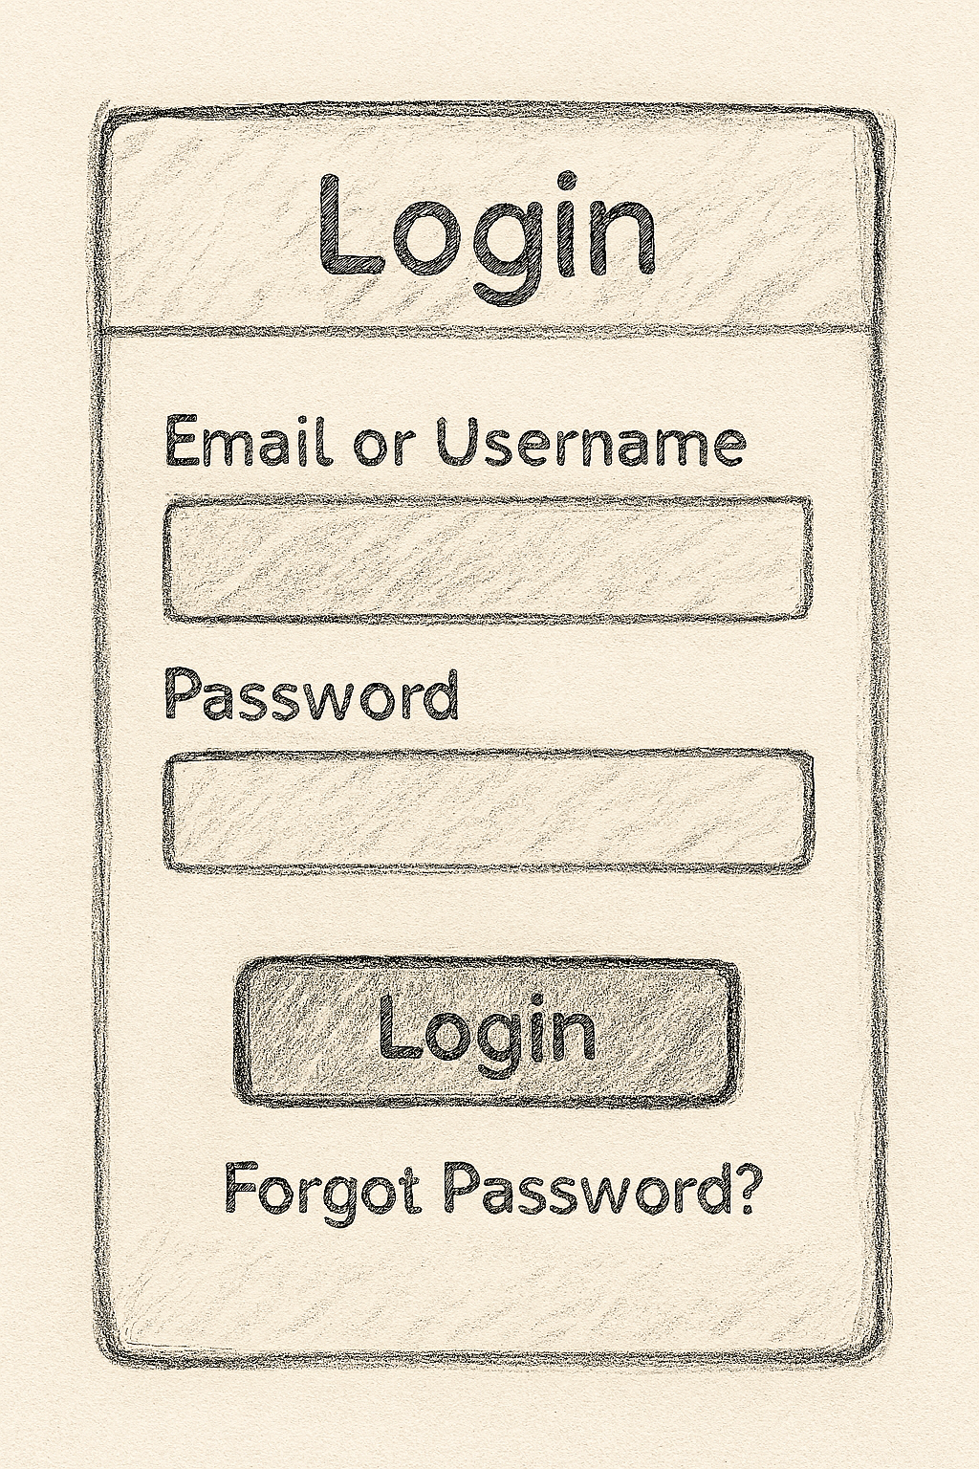

**2.2.2 Sign Up Form Design**

*The sign‑up form enables new users to register. It collects name, email, phone number, and password, ensuring proper onboarding.*

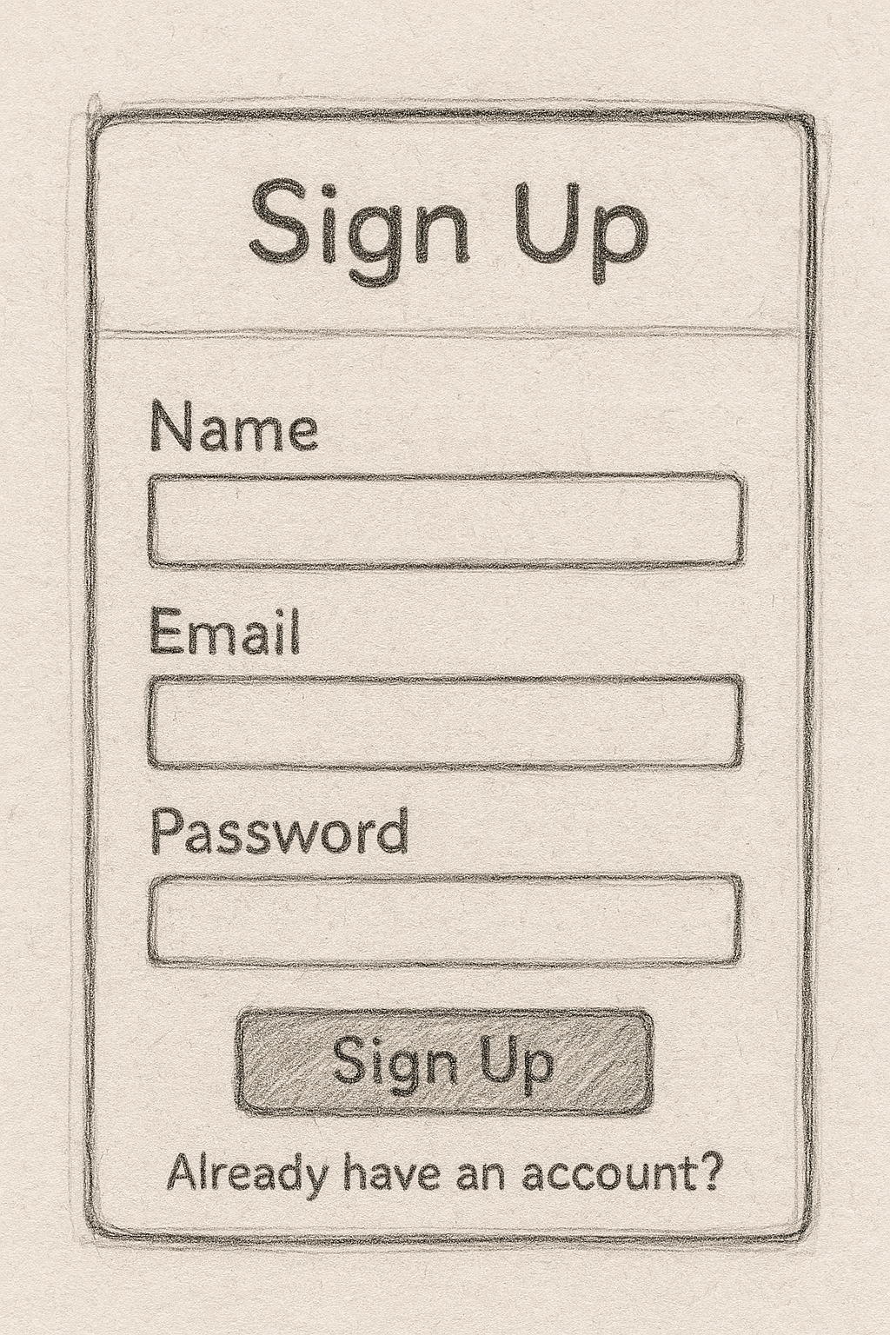

**2.2.3 Products Page Design**

*This page displays client furniture designs, measurements, and instructions in a structured table or card layout. It allows filtering by client name, order status, or date.*

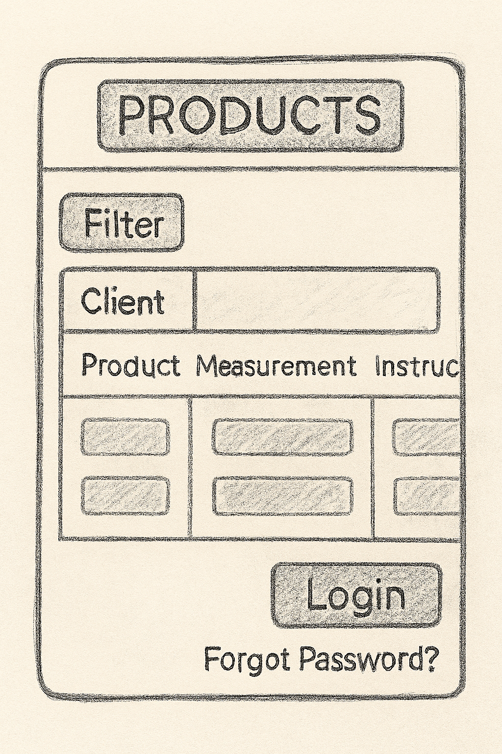

***2.3 Logic Models***

**2.3.1 Login Process Flowchart**

*Shows how the system validates credentials, checks against Firebase database, and grants/denies access.*

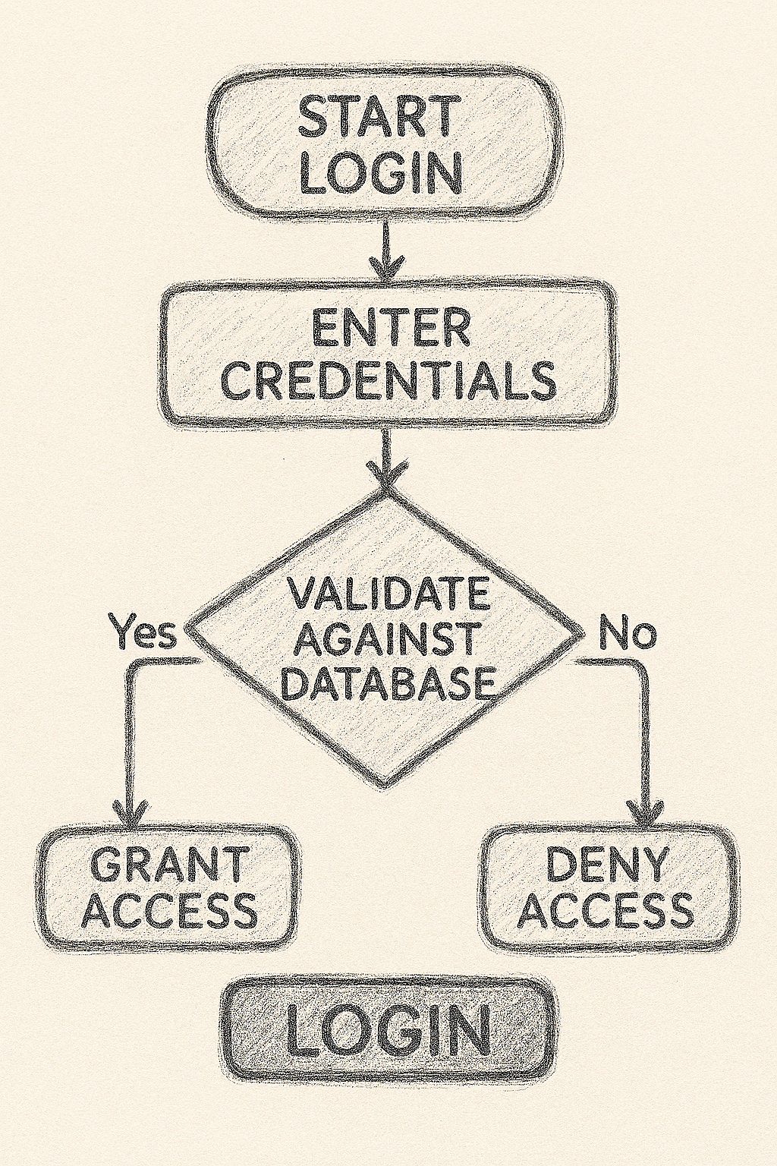

***2.3.2 Purchase/Checkout Process Flowchart***

*Illustrates how a client order moves from selection → confirmation → database storage → receipt generation.*

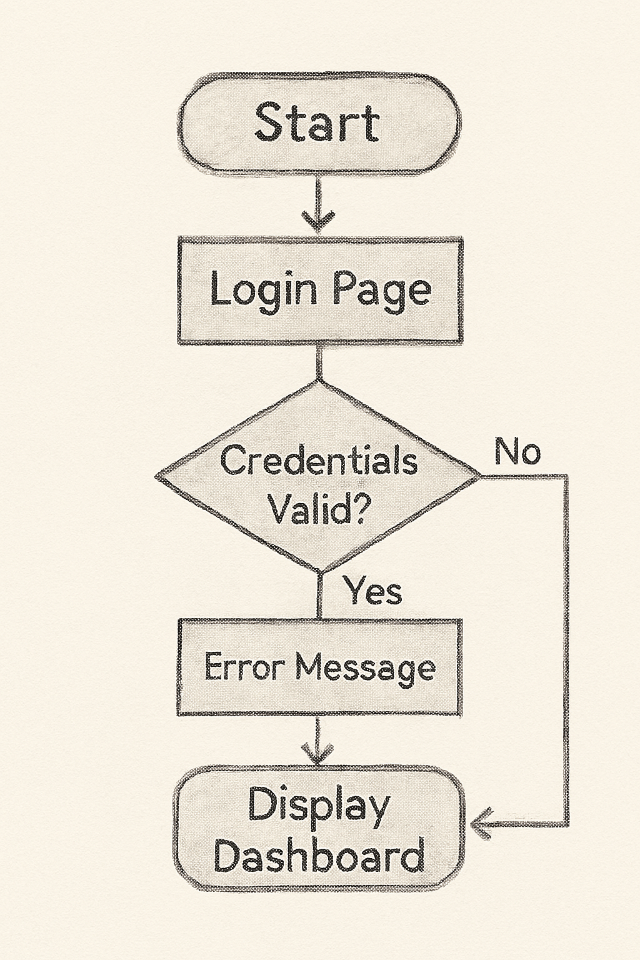

***2.3.3 Class Diagram for the System***

*Represents system entities:* ***User, ClientOrder, Product, Measurement, Instruction****, and their relationships.*

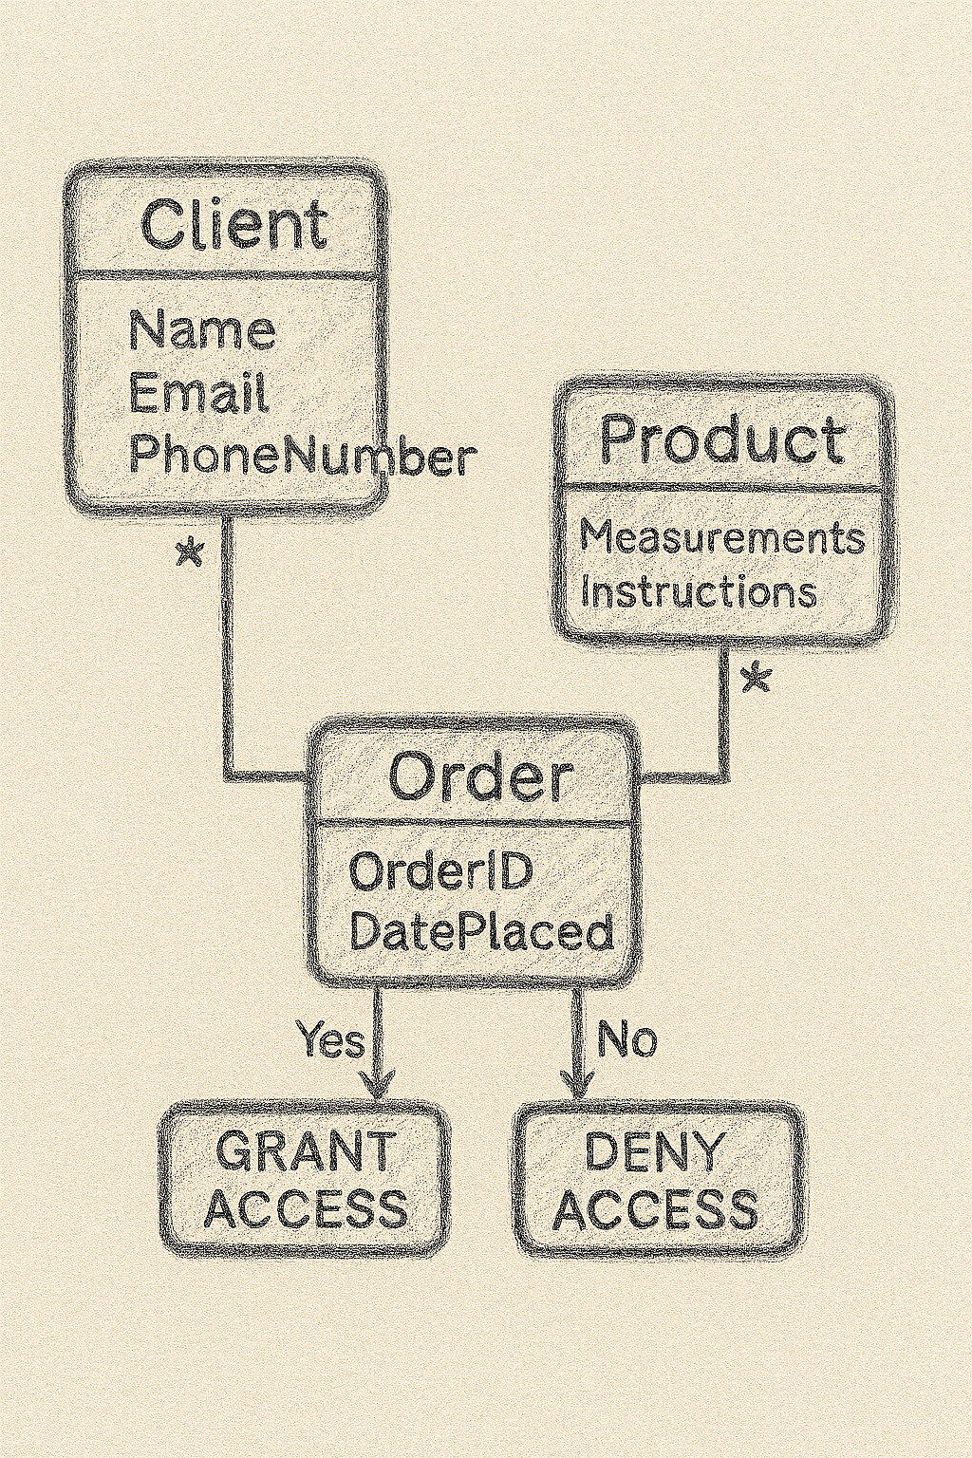

***2.3.4 Enquiry Flowchart***

*Depicts how a client enquiry is submitted, processed, and responded to within the system.*

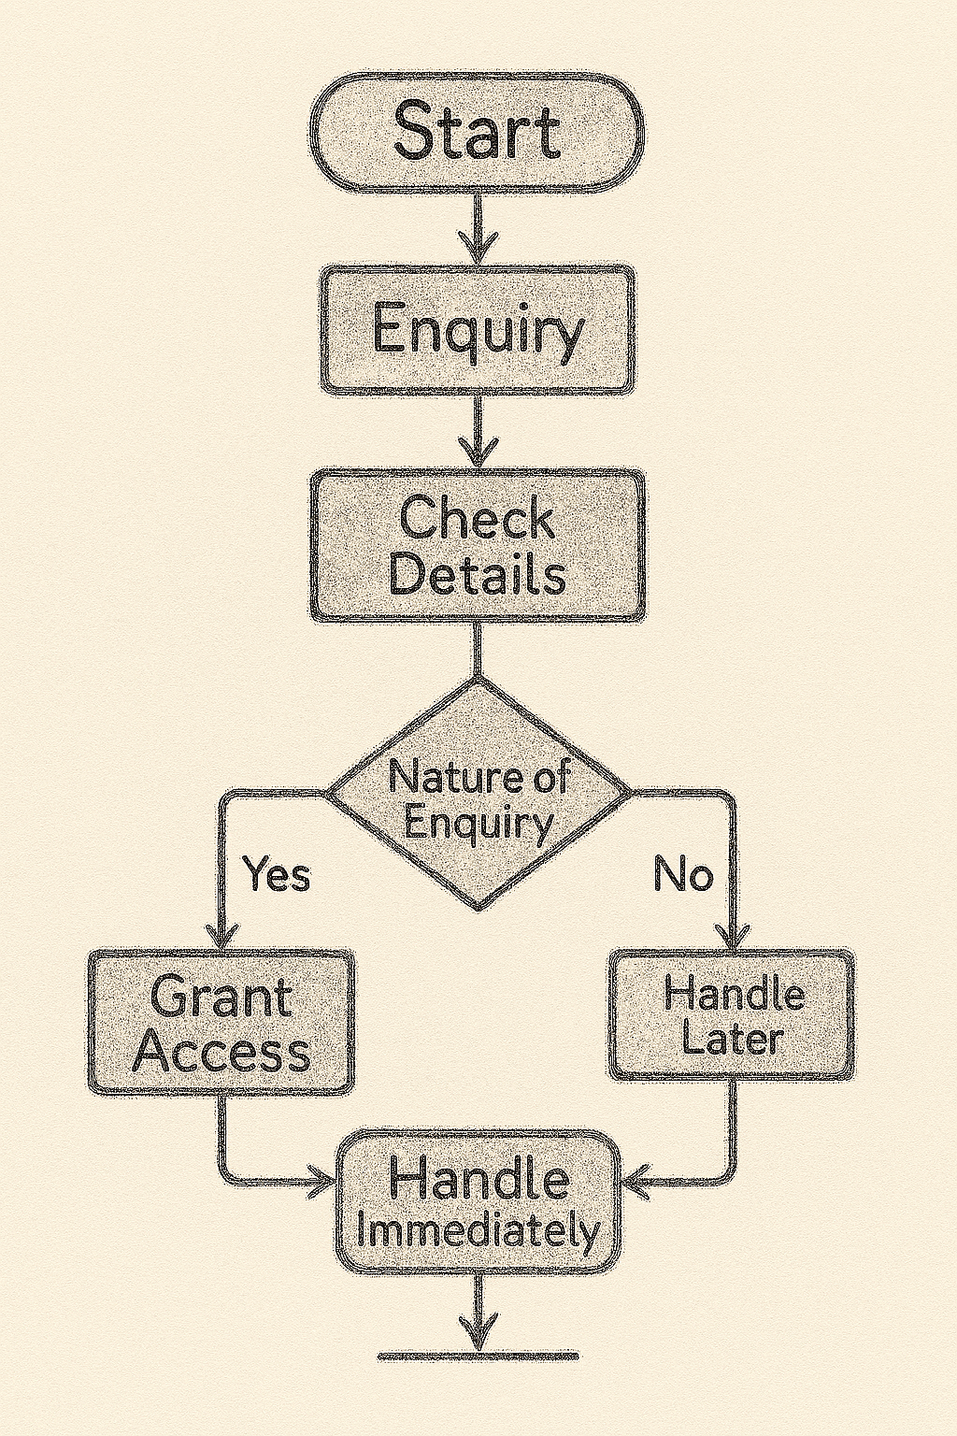

# **CHAPTER THREE: WORKPLAN**

## **3.1 Introduction**

This section presents a plan for the project that will begin after gaining a clear understanding of how furniture manufacturers currently manage client designs, measurements, and instructions often through fragmented manual and digital methods and the challenges this disorganization creates in production accuracy, speed, and customer satisfaction. It also follows a review of several digital solutions examining their features, hardware and software needs, budget requirements, and the skills necessary to develop them.  
Based on feasibility findings, this chapter will detail which digital solution will be pursued as the project. It will outline the system’s functional requirements, the project goals, the tools and resources required, and the skills involved in development. A time schedule will also be presented to show how the work will progress from the start of the next semester to completion.

## **3.2 Feasibility Assessments**

**Table 3.2 Feasibility Assessments**

|  |  |  |  |  |
| --- | --- | --- | --- | --- |
|  | **POROJECT MILESTONE** | | | |
| **1** | **2** | **3** | **4** |
| **WEEKS** | **Project design &**  **modeling** | **Project development**  **&**  **testing** | **Project deployment** | **Project presentation** |
| 1 - 5 Sep |  |  |  |  |
| 8 - 12 Sep |  |  |  |  |
| 15 - 19 Sep |  |  |  |  |
| 22 - 26 Sep |  |  |  |  |
| 29 sep-3 Oct |  |  |  |  |
| 6 – 10 Oct |  |  |  |  |
| 13 – 17 Oct |  |  |  |  |
| 20 – 24 Oct |  |  |  |  |
| 27 – 31 Oct |  |  |  |  |
| 3 –7 Nov |  |  |  |  |
| 10 – 14 Nov |  |  |  |  |
| 17 – 21 Nov |  |  |  |  |
| 24 – 28 Nov |  |  |  |  |

***Table 3.2 Feasibility Assessment Table***

**3.3 Project Justification**

The above method is justified by the various ways to address inefficiencies in the way furniture manufacturers manage customer designs, measurements, and instructions. People rely on fragmented manual records or fragmented digital data, which leads to miscommunications, production errors, and disgruntled consumers.

By building a centralized digital platform with open-source technologies, this project offers a reliable solution that improves data organization, retrieval, and accuracy. It allows firms to increase consumer trust, reduce material waste, and smooth operations without incurring further expenses.

The system provides a learning opportunity for full-stack web development, database integration, and user-centered design. Its affordability for business needs, and alignment with academic goals make it the ideal option for a semester-long project.

**SYSTEM IMPLEMENTATION**

**(DEVELOPMENT, TESTING AND DEPLOYMENT)**

*This is where you report on your development journey e.g. from when you downloaded your IDEs, and coding, to implementing your database to deploying your system*

**3.1 Introduction**

This chapter narrates the development journey: setting up IDEs (VS Code, Firebase console), coding interfaces, implementing database connections, and deploying the system. It highlights challenges faced and solutions applied.

**3.2 User Interface Development**

*Your system has two sides – the user side (where different users can interact with the system) and the logic side.*

*Under this section you will screenshot all the User Interfaces you have built (login pages, sign up forms, report page, dashboard, etc.) and the code for them if you built them from scratch, e.g. a screenshot of the html and css code for sign up form.*

*Organize them into subheadings e.g. 3.2.1 Login Page Development (under this section, a brief explanation of what it’s been built for, a screenshot of the page and a caption underneath it, screenshots of its html and css code used to develop it, and captions underneath every screenshot)*

**3.3 Logic Development**

*Your system has two sides – the user side (where different users can interact with the system) and the logic side. The logic side is how the system is performing activities using data e.g. login validation, processing checkout and generating a receipt, storing data into database, retrieving products from DB and showing them on a certain page. This is called logic.*

*Under this section you will screenshot all the* ***Codes*** *that handle different processes/activities. Organize them into subheadings e.g. 3.3.1 Login Validation Code (herein, explain in brief how the system handles login, take screenshots of the login validation code, and caption it)*

**3.4 Testing**

Document test cases (e.g., login with wrong password, order submission with missing fields) and corrections made.

**3.5 Deployment**

*Say on what platforms did you deploy your system (e.g. if it’s a website, what web hosting platform did you use – and copy paste a link to your website, if it’s an android application – the process of putting up your app on Google Playstore.). Essentially, detail out the process of how you converted your project into a form that can be run/installed by anybody.*

Explain hosting on Firebase Hosting or GitHub Pages, with a link to the deployed system.

**CHAPTER FOUR: CONCLUSION AND RECOMMENDATION**

**4.1 Conclusion**

*A paragraph summarizing chapter one, two and three. And finish by telling us what new things you learnt during the entire time developing your project, and challenges faced.*

**4.2 Recommendation**

This project addressed inefficiencies in furniture order management by proposing a centralized digital system. Through literature review, modelling, feasibility analysis, and implementation, the study demonstrated how automation and digital tools enhance accuracy, reduce errors, and improve customer satisfaction. Challenges included limited resources and integration complexity, but valuable lessons in full‑stack development and project management were gained.

***NB: Recommendation is not an excuse for a NOT WORKING system, e.g. it is not saying that your system can’t store any data because you didn’t have the time to implement a database, No. It is a suggestion for how your ALREADY WORKING SYSTEM (with the lower technologies you’ve used) can be MADE BETTER, with HIGHER/BETTER TECHNOLOGIES. E.g. you used MySQL to store structured data, suggest for them to use a NO-SQL approach to store non-structured data like customer feedback and product reviews.***

**4.2 Recommendation**

Future developers could:

* Integrate biometric login for enhanced security.
* Add mobile app support for on‑site furniture makers.
* Use AI‑powered CAD integration for automatic design interpretation.
* Expand database to NoSQL for unstructured data like customer reviews.
* Connect with payment gateways (MPESA, card payments) for seamless transactions.

**REFERENCES**

**Academic & Industry References**

Ratnangi, J. (2022). *Furniture Manufacturing: A Production Engineering Approach*. Springer Nature.

* + Covers automation, digital transformation, and Industry 4.0 in furniture manufacturing.
  + [Available via SpringerLink](https://link.springer.com/book/10.1007/978-981-16-9412-7)

Barros, M., Duarte, J. P., & Chaparro, B. M. (2014). *Integrated Generative Design Tools for the Mass Customization of Furniture*. In *Design Computing and Cognition DCC’12*, Springer.

* + Explores CAD-CAE integration and parametric modeling for furniture customization.
  + [Read the full paper](https://www.researchgate.net/publication/268981637_Integrated_Generative_Design_Tools_for_the_Mass_Customization_of_Furniture)

CloudCyberCore (2025). *Cloud Security for the Furniture Industry: Protecting Data and Driving Innovation*.

* + Discusses cloud-based ERP integration, supply chain resilience, and cybersecurity in furniture workflows.
  + [Explore the case study](https://www.cloudcybercore.com/post/cloud-security-for-the-furniture-industry-protecting-data-and-driving-innovation)

NetworkON (2024). *Streamlining Furniture Delivery: The Power of Innovative Furniture Delivery Management Software*.

* + Focuses on logistics, route optimization, and real-time tracking in furniture delivery systems.
  + [Read the article](https://networkon.io/resources/blog/streamlining-furniture-delivery-the-power-of-innovative-furniture-delivery-management-software)

Flatma AI (2025). *AI-Powered 3D Furniture Design and Manufacturing Tools*.

Offers insights into AI-generated technical drawings, cutlists, and digital fabrication workflows.

[Visit Flatma’s platform](https://flatma.com/en/)

Smith, A., Brown, K., & Liu, F. (2022). Digital transformation in small-scale manufacturing: A comparative study. *Global Journal of Manufacturing Research*, 27(4), 233-248.